Unify AC Quick Start User Guide

Revision: 1.2
Revision | Date | Description
1.0 | 2026-04-27 | Initial release  This firmware v1.0.4.24 requires fresh installation
1.1 | 2026-06-04 | Optimize AC upgrade experience and add OTA online upgrade capability, firmware v1.0.4.30 version
1.2 | 2026-06-15 | Add Features, firmware v1.0.4.32 version

1. Document Overview

1.1 Purpose
This guide helps users quickly complete the initial deployment and basic configuration of the Unify AC system, covering core operations such as hardware connection, Web management interface login, default network parameter setup, and activation of the first wireless service. All steps are verified based on the UnifyAC_CR_1.0.4.32 firmware version, ensuring ready-to-use and zero touch setup.

1.2 Target Audience
This guide is intended for network administrators, IT operation and maintenance personnel, and integration engineers who are new to the Unify AC system. No advanced experience in wireless controller configuration is required. Readers should be familiar with basic TCP/IP network concepts and Web browser operations.

1.3 System architecture
Westala Unify AC supports standalone mode and high availability mode. Unify AC supports centralized forwarding and local forwarding modes, while Soft AC only supports local forwarding mode.
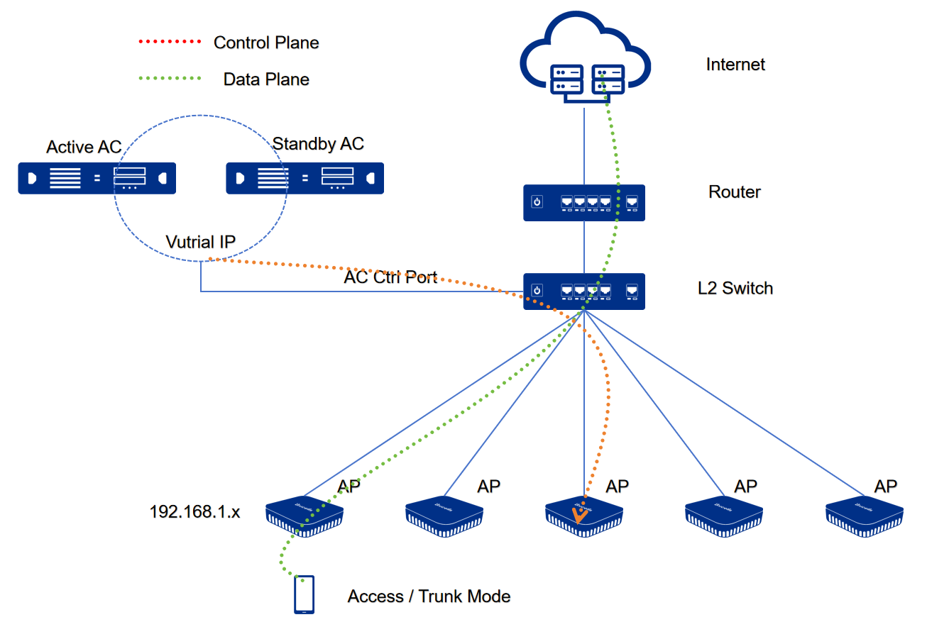

1.4 System Requirements
All VMs adopt 64-bit architecture with hardware-assisted virtualization (Intel VT-x / AMD-V) enabled. Specifications are scaled by managed AP quantity and concurrent wireless users.
Deployment Scenario | Managed Scale | CPU / vCPUs | Memory | System Disk | Network Adapter
Small-Scale | ≤ 50 APs  ≤ 2500 STAs | 2 Cores | 4 GB | 100 GB SSD/HDD | 1 x 1G
Medium-Scale | 50 – 500 APs  2500 - 10000 STAs | 4 Cores | 8 GB | 200 GB High-Performance SSD/Cloud Disk | 2 x 1G/10G
Large-Scale | ≥ 500 APs  ≥ 10000 STAs | 16 Cores | 32 GB+ | 480 GB High-Performance SSD/Cloud Disk | 2 x 10G

2. Installation Guide
This document covers various installation solutions for Unify AC, including VMware Workstation installation, ESXi installation, cloud installation, and physical machine local installation.

2.1 VMware Installation

2.1.1 Host System Requirements
- CPU
  - Architecture: 64-bit x86/AMD64
  - Must support and enable: Intel VT-x or AMD-V (SVM) virtualization extensions (must be set to Enabled in BIOS/UEFI)
  - Recommendation: 4 cores or above, main frequency ≥ 2.5GHz
- RAM
  - Minimum: 8GB
  - Recommendation: 16GB
- Storage
  - Minimum: 100GB
  - Recommendation: 200GB
- VMware Version
  - Recommendation: VMware Workstation Pro 16/17

2.1.2 Installation Steps from a ovf images on Vmware Workstation
Step 1: Obtain the Image
Log in to
https://downloads.westala.us/
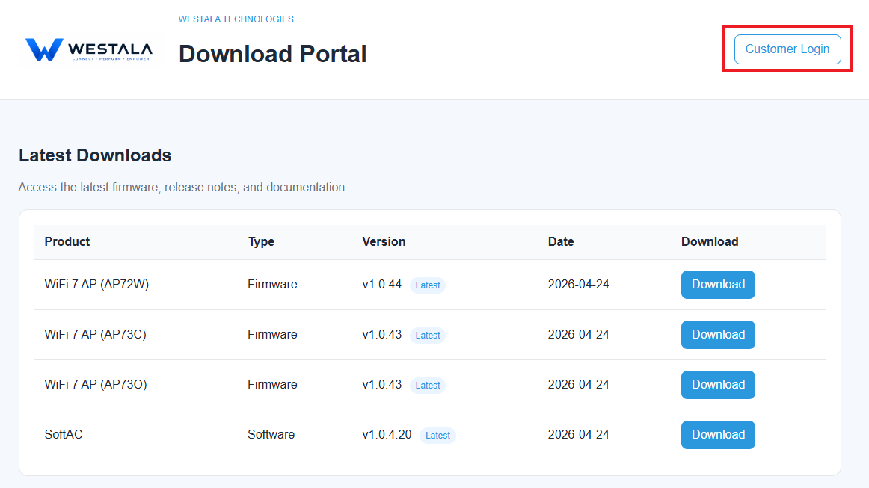
Download the latest UnifyAC image to your local device.
For the login information, please contact your local sales or send an email to info@westalatech.com.

Step 2: Import the Image
In the VMware interface, select Open a Virtual Machine, choose a firmware named like UnifyAC_CR_1.x.x.x.ovf, enter a virtual machine name, and complete the loading process.
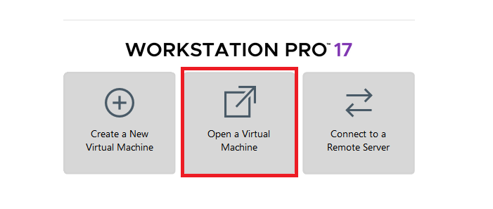

Step 3: Confirm VMware Network configurations
- Confirmed the VMnet0 has been Bridged to the correct physical network adapter.
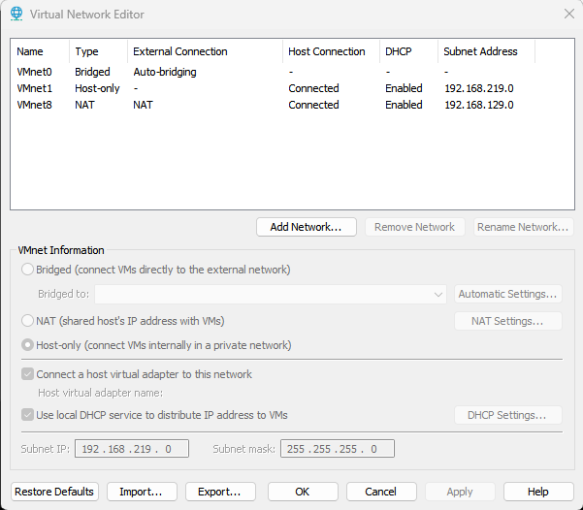
- Confirmed the VM’s Network Adaptor Mode to Bridged
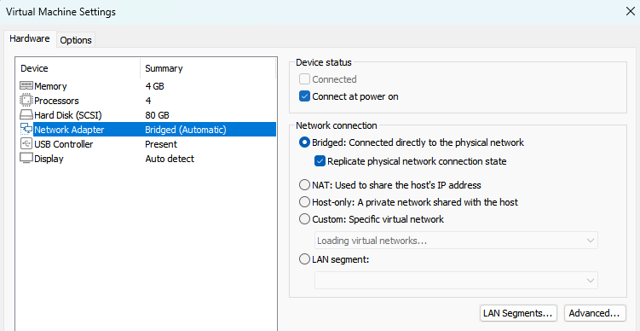

2.1.2 Installation Steps from a iso images on Vmware Workstation
Step 1: Create a new Virtual Machine
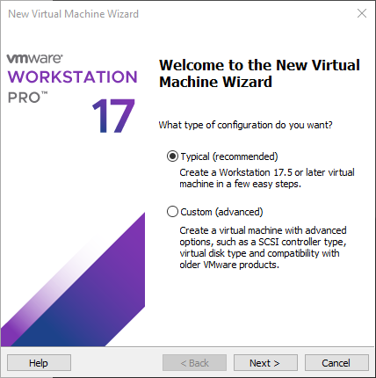

Step 2: Installation
Step 2.1 Select .iso file
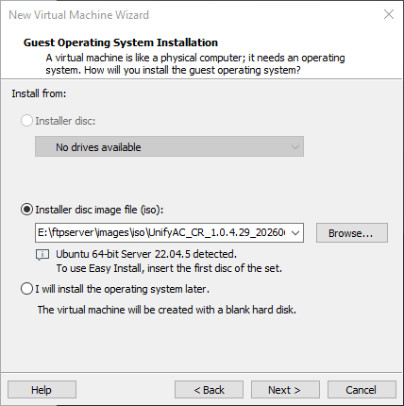
Step 2.1 VM Configurations
VM Configuration | Recommend Specs
VM Name | UnifyAC_CR_x.x.x.x
Specify Disk Capacity | 100 / 200GB  Recommended Store virtual disk as a single file
Memory | 8GB / 16GB
Processors | 4 cores
Network Adapter | Bridged
Power on Selection | Power on this virtual machine after creation
Step 2.3 Installation
After virtual machine creation completes, the VM powers on automatically.
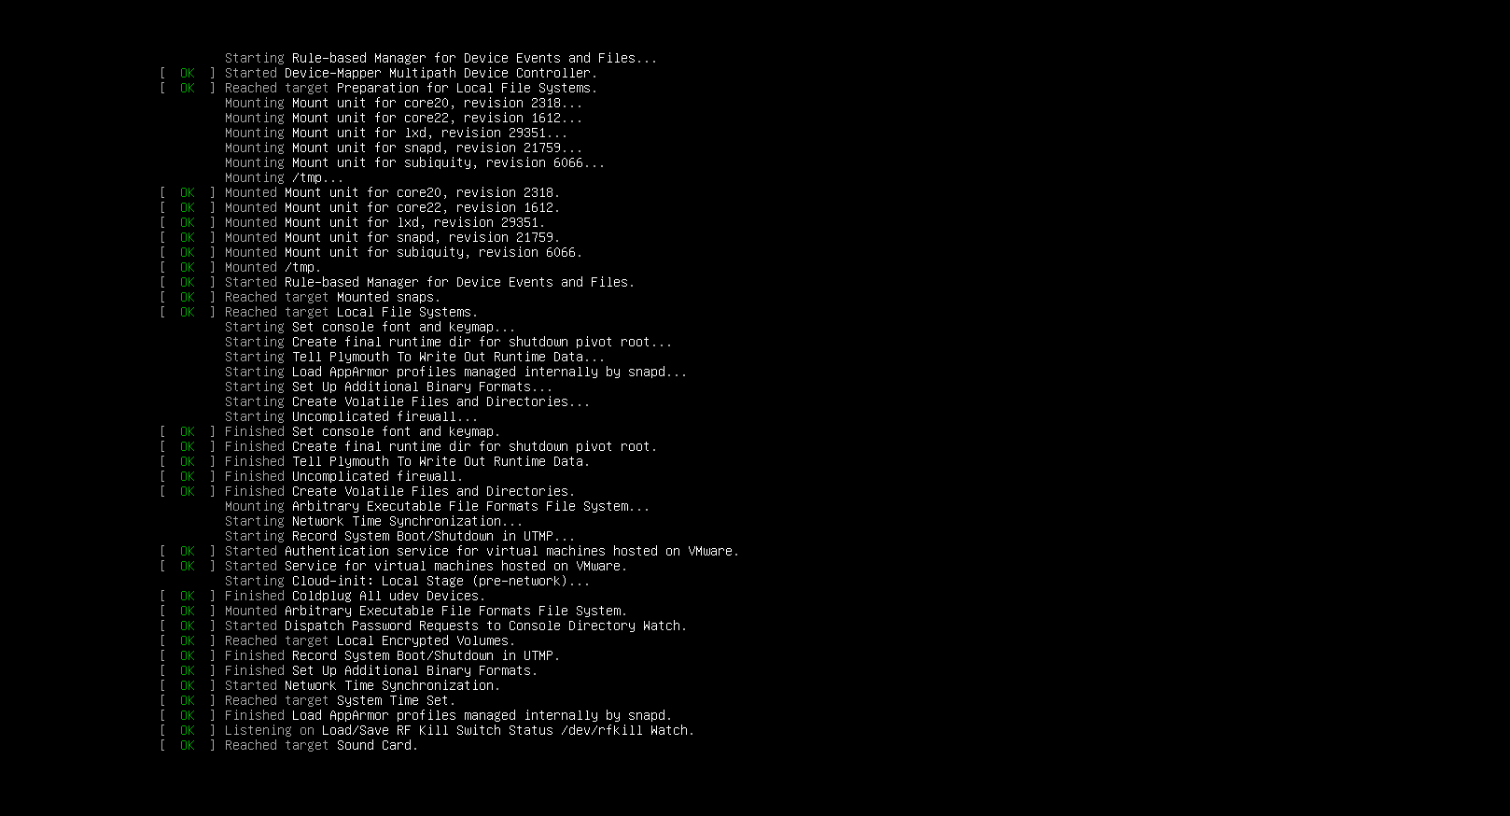
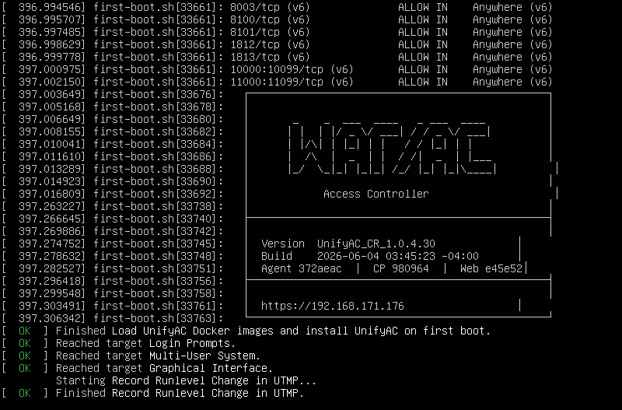
The screen displays Linux kernel boot logs and the systemd initialization sequence.
The system then proceeds to unattended automated installation with real-time progress indicators shown on-screen. Do not shut down the VM or perform any manual operations during installation; wait for the setup to finish automatically.

2.2 ESXi Installation

2.2.1 Host System Requirements
- CPU
  - Architecture: 64-bit x86/AMD64
  - Must support and enable: Intel VT-x or AMD-V (SVM) virtualization extensions (must be set to Enabled in BIOS/UEFI)
  - Recommendation: 4 cores or above, main frequency ≥ 2.5GHz
- RAM
  - Minimum: 8GB
  - Recommendation: 16GB
- Storage
  - Minimum: 100GB
  - Recommendation: 200GB
- VMware ESXi Version
  - Recommendation: ESXi 7.0 U2 or Higher

2.2.2 Installation Steps
Step 1: Create a new Virtual Machine
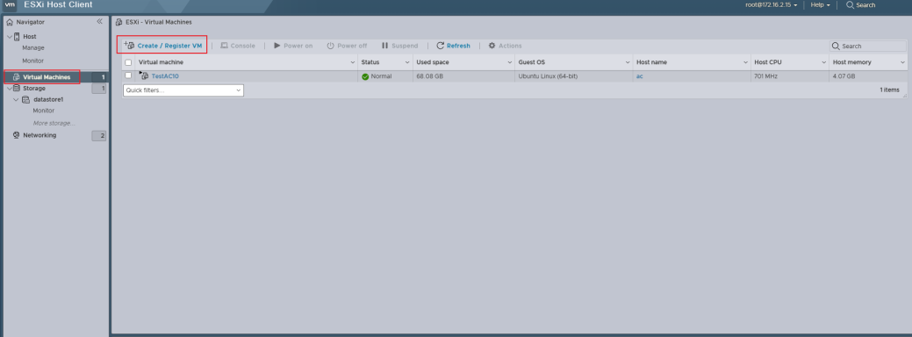

Step 2: Installation
Step 2.1 Select .iso file
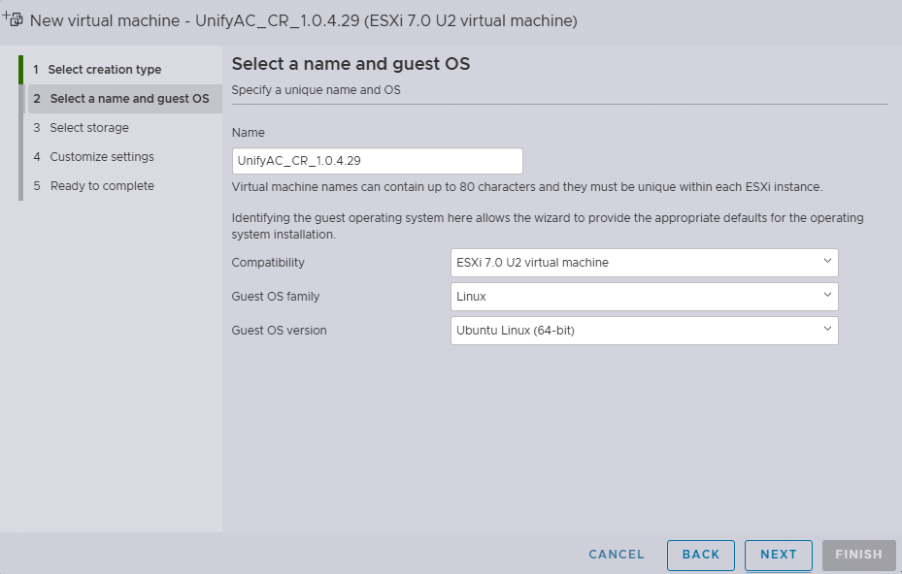
Step 2.2 VM Configurations
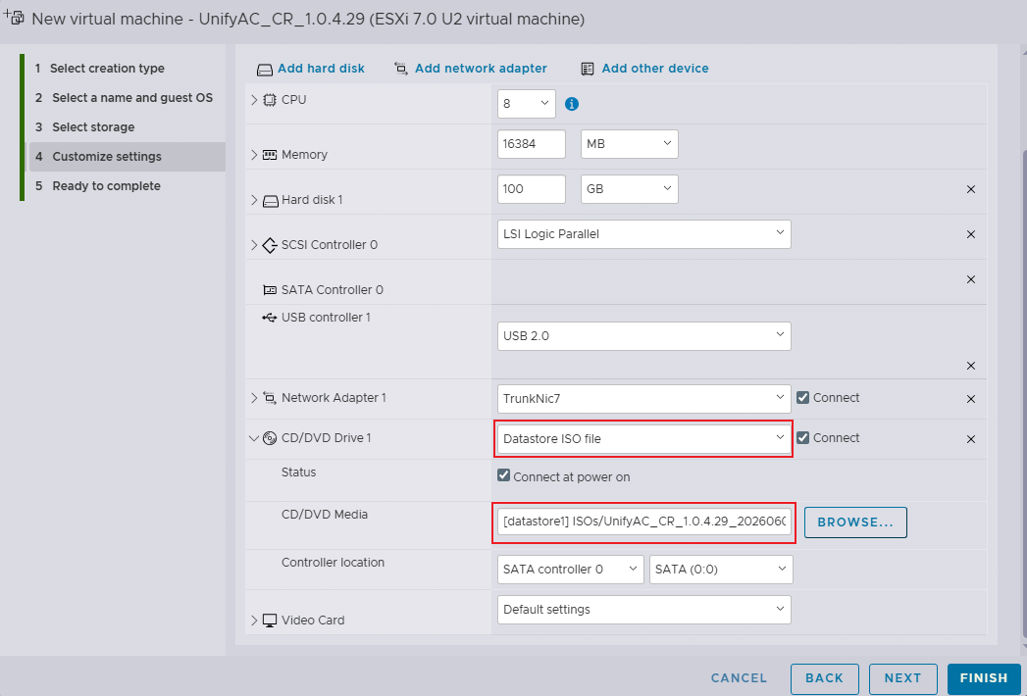
VM Configuration | Recommend Specs
VM Name | UnifyAC_CR_x.x.x.x
Compatibility | ESXi 7.0 U2 virtual machine
Guest OS family | Linux
Guest OS version | Ubuntu Linux (64-bit)
Specify Disk Capacity | 100 / 200GB  Recommended Store virtual disk as a single file
Memory | 8GB / 16GB
Processors | 4 cores
Network Adapter | Bridged
Note: Before installation, confirm the ISO image file has been uploaded to the ESXi datastore.
Upload the ISO via vSphere Client: navigate to Storage > select target datastore > Datastore browser.

Step 2.3 ESXi Console Start
After the virtual machine boots up, the console outputs the Ubuntu boot sequence. The OS loads its kernel and initializes services. The on-screen prompt Waiting for cloud-init... signifies the system is undergoing initial configuration.
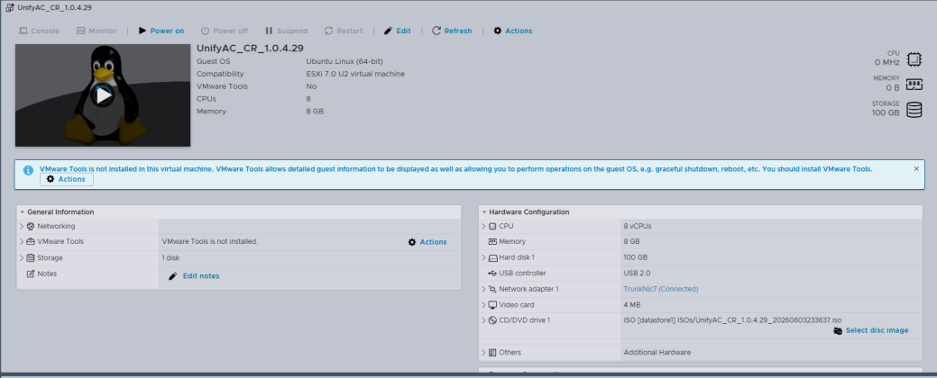

Step 2.4 Installation
The system enters the automated installation phase, where the first-boot.sh script runs automatically to extract and install required software packages including Python, network utilities and system components. Do not power off the virtual machine or perform any manual operations during installation; wait for the process to complete automatically.
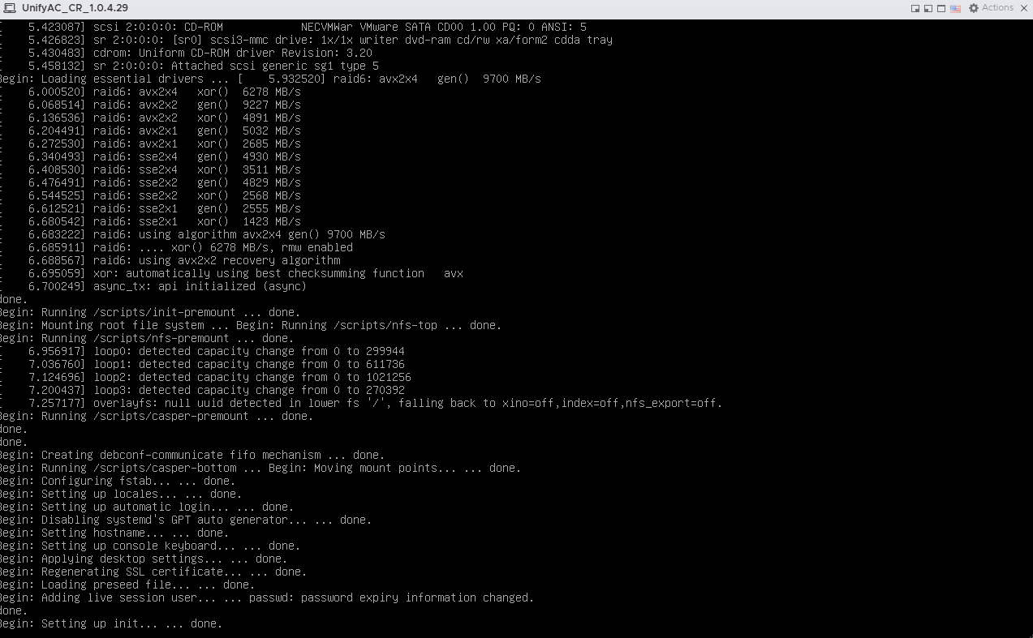
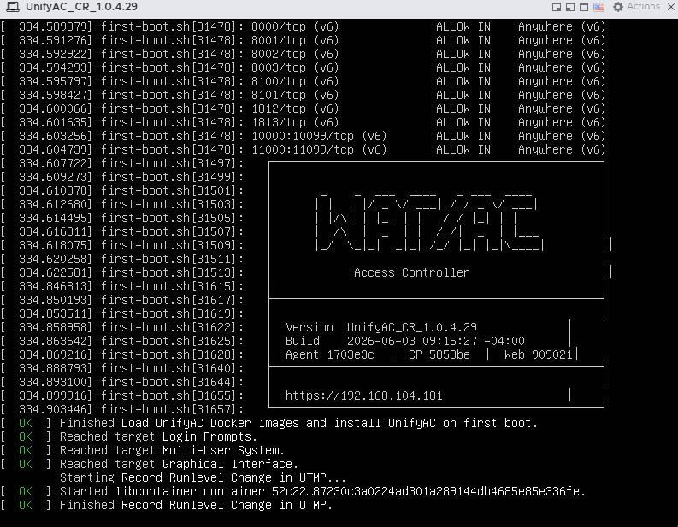

2.3 Getting Start
Step 1: Get the Management IP
For convenient web-based operation and maintenance, the DHCP function of the UnifyAC management port is enabled by default. After the AC finishes booting (about 3~5 minutes), the WebGUI address of the AC will be automatically displayed on the screen.
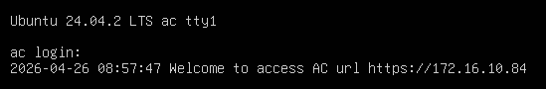
The management address also can be obtained by CLI command
- LOGIN

Username: ac
Password: admin
- Run the rt show command to view the management port configuration
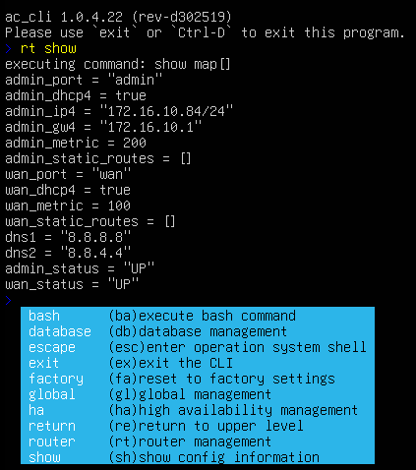

Step 2: Log in to the UnifyAC
Log in to
https://ac-address/

Login name: admin
Password: admin
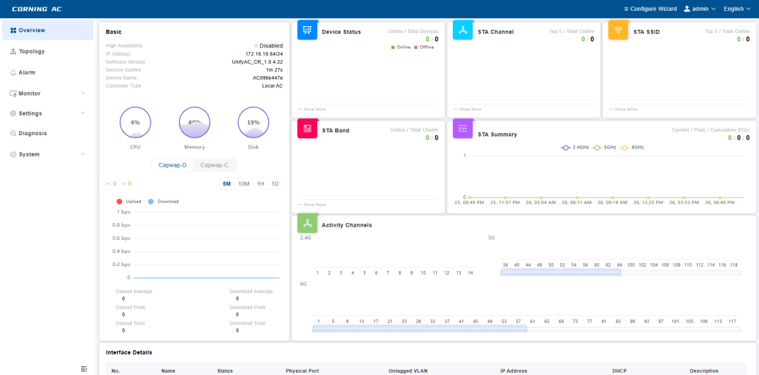

Step 3: Configure the management IP
Settings > Network > Route > MGMT
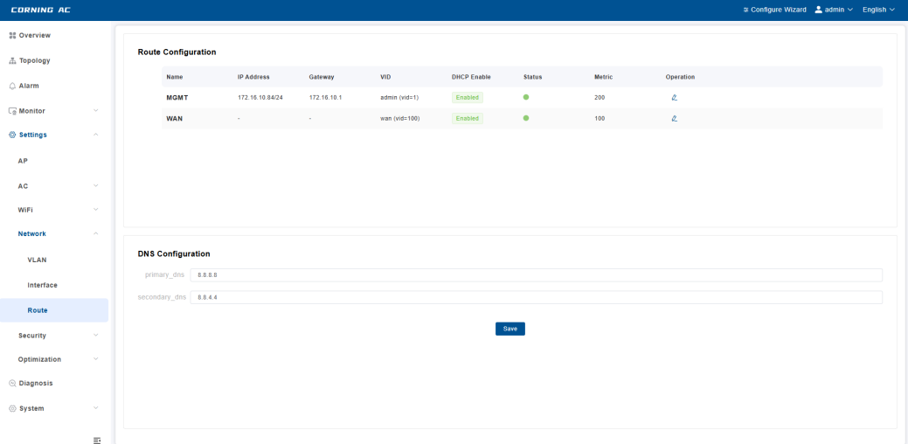

3. Upgrade Guide

3.1 Backup Settings
System > Restart & Restore > WiFi Settings > Export WiFi Settings
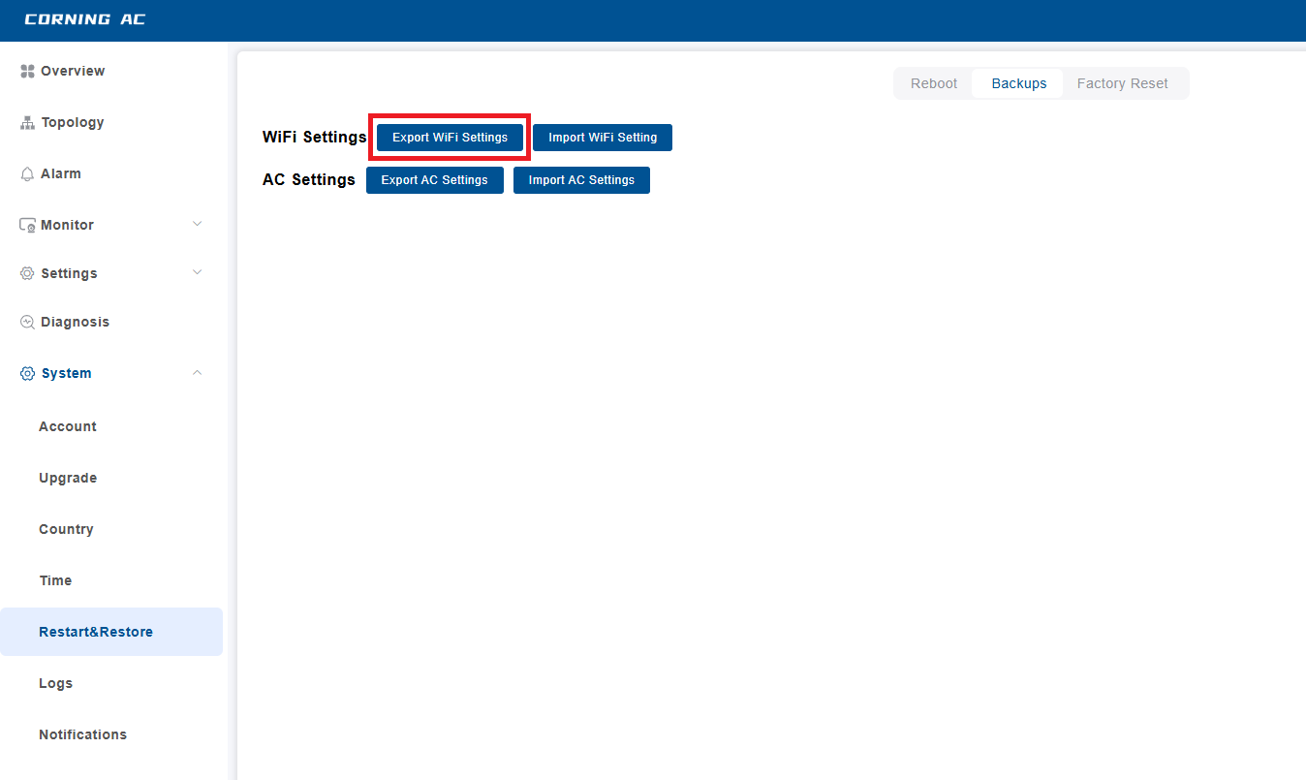
Figure 1
The default storage Folder will be at: C:\Users\Administrator\Downloads

3.2 Firmware upgrade

3.2.1 OTA Upgrade*
Note: OTA Server will available in near future
Download and install firmware directly from the update server, when a new firmware version is available, an Update Available button with a warning icon appears in the top header bar.
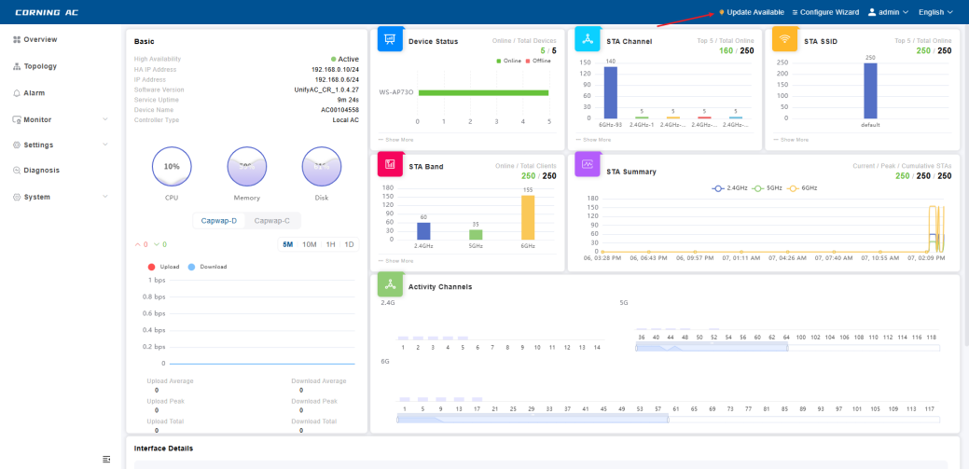
Step 1: Clicking it navigates directly to the Upgrade page
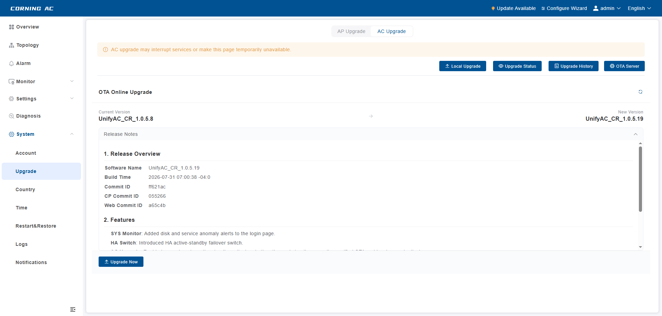
On the Upgrade page, the OTA Online Upgrade section displays the current firmware version and the latest available version for upgrade. Click the refresh icon next to the section title to manually check for the latest version.
The Release Notes section provides a summary of changes included in the new firmware version.
Step 2: Start Upgrade
Tap Upgrade Now to open the dialog, then tap Confirm to start the upgrade.
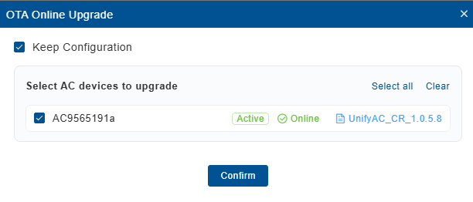
- Keep Configuration: When checked, the existing configuration will be retained after the upgrade. If unchecked, all user data will be cleared.

Note: Do not power off or close the browser during this process

3.2.2 Local Upgrade
Upload a firmware file from your local machine to perform the upgrade manually.
Step 1: Obtain the files
Local Archive: UnifyAC_CR_x.x.x.tar.zst
Step 2: Access the Upgrade Page
Expand the `System` menu in the left navigation bar and click `Upgrade`. On the upgrade page, confirm the `AC Upgrade` tab is selected, then click the `Check for Updates` button.
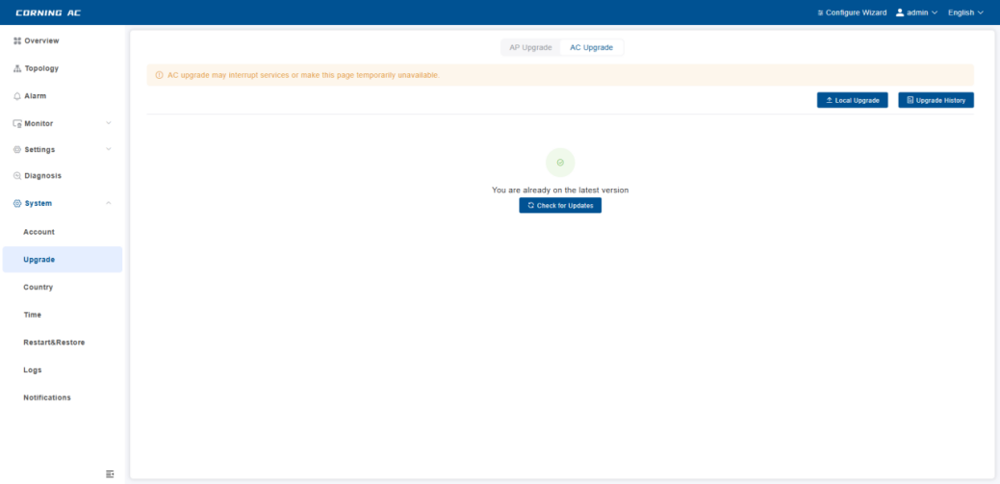
Step 3: Upload the Upgrade File
A Firmware Upgrade dialog will appear. Click or drag-and-drop to select the prepared .tar.zst upgrade file (e.g., UnifyAC_CR_1.0.4.30.tar.zst) in the upload
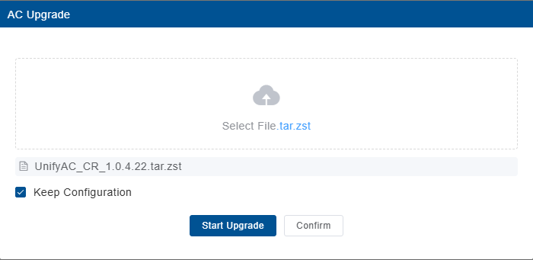
Step 4: Confirm Configuration Retention
After selecting the file, verify that the Keep Configuration checkbox is checked (enabled by default) to retain current system settings. Then click the Start Upgrade button to begin the upgrade.
Step 5: Confirm Upgrade Start
When the system is ready, a confirmation dialog appears with the message: "Confirm to start upgrade? The AC will reboot during the upgrade. You will be redirected to the login page after completion." Click Confirm to proceed.
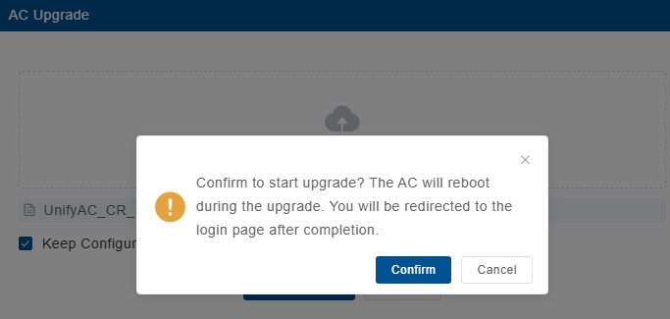
Step 6: Wait for File Upload
The system begins uploading the upgrade file. The page displays Uploading... with a progress bar. Please wait patiently for the upload to complete.
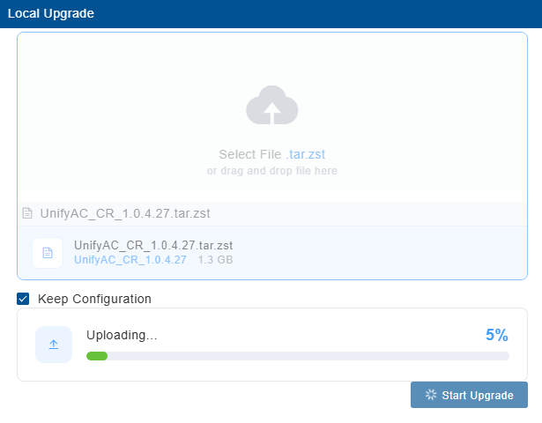
Note: Do not power off or close the browser during this process
Step 6: Wait for Upgrading Processing
Once the upload is complete, the system automatically enters the upgrade processing phase. The page displays Processing with a progress bar. Do not power off or close the browser during this process.
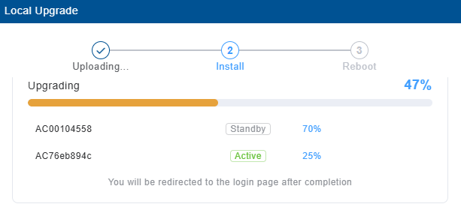

Step 7: Wait for System Reboot
After confirmation, the system automatically reboots. The page displays "System is restarting, please wait". Wait for the reboot to complete. Once finished, the page will automatically redirect to the login page. Log in again to access the system.
