Release Notes UnifyAC_CR_1.1.0.5

1. Release Overview
Product | Corning AC (UnifyAC)
Version | UnifyAC_CR_1.1.0.5
Release Date | 2026-09-30
Build ID (Commit ID) | 8022ceb, c75a40, 70eba7
Release Type | Maintenance Release
Upgrade Recommendation | Recommended
2. Supported Platforms
- Corning AC (UnifyAC)
3. Key Highlights
- DPSK Function Enhancement: Support binding of DPSK and VLAN.
- STA List Enhancement: Enable quick navigation from the STA list to AP Detail page.
- SSID Configuration Page: Restrict users from selecting centralized forwarding in VM deployment scenarios to prevent performance degradation of VM-based centralized forwarding and poor user experience.

- New Features
- DPSK Function Enhancement
- Support binding of DPSK and VLAN
- New DPSK Setting Page
- DPSK Batch Import & Export
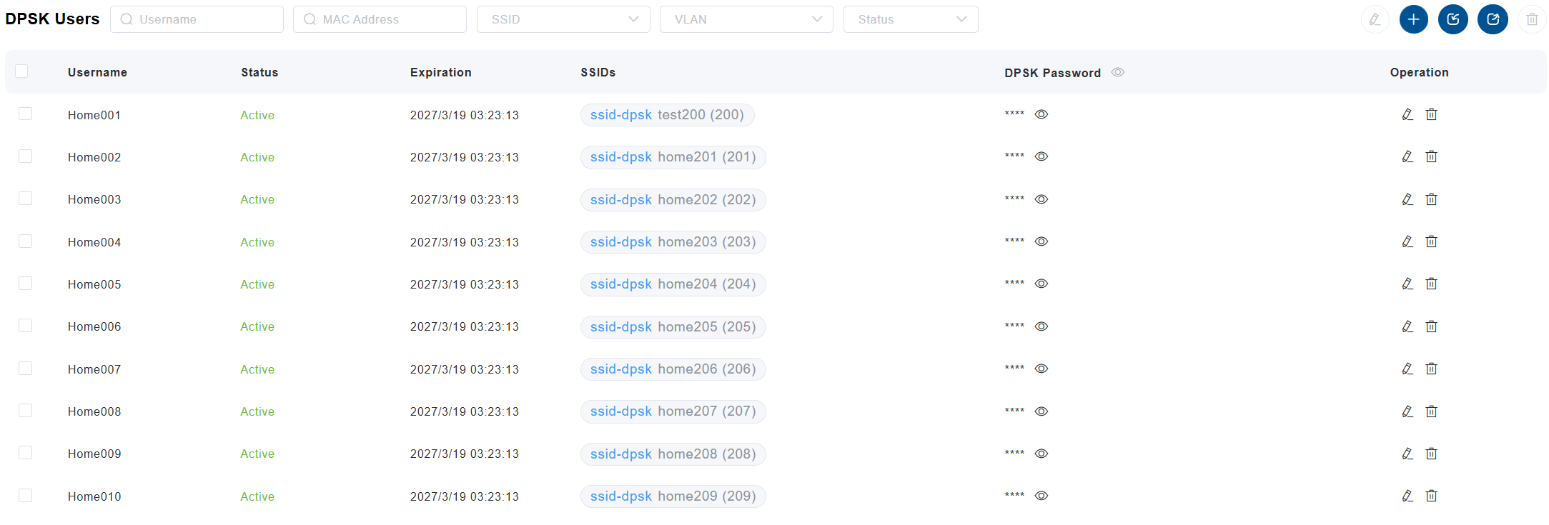
- STA List Enhancement
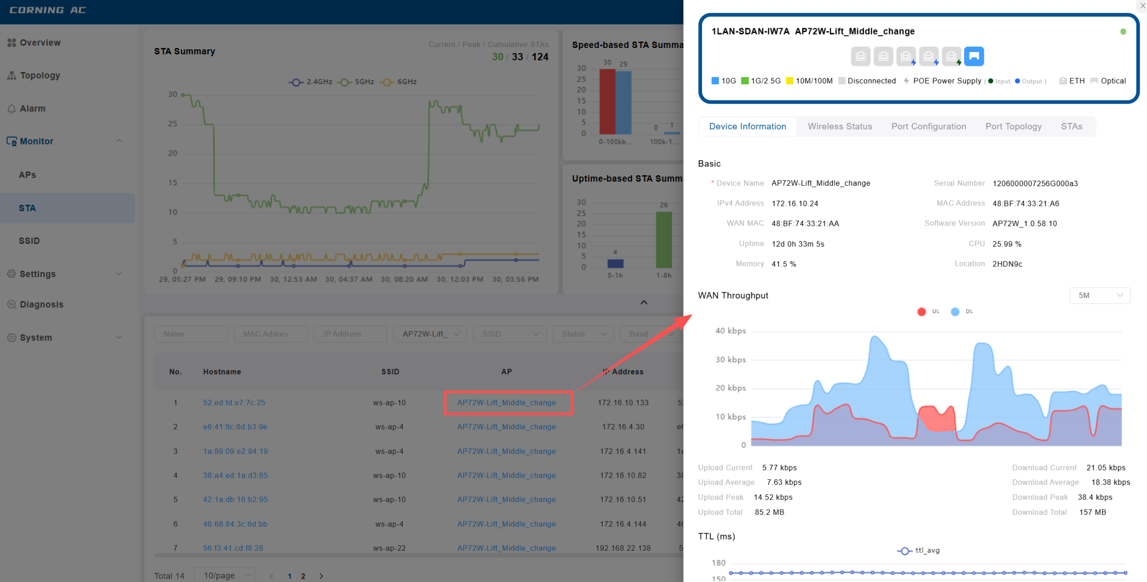
Enable quick navigation from the STA list to AP Detail page.
- SSID Centralized Forwarding Restriction
Restrict users from selecting centralized forwarding in VM deployment scenarios to prevent performance degradation of VM-based centralized forwarding and poor user experience.
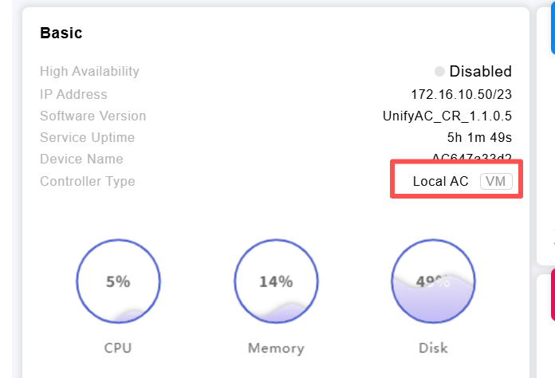
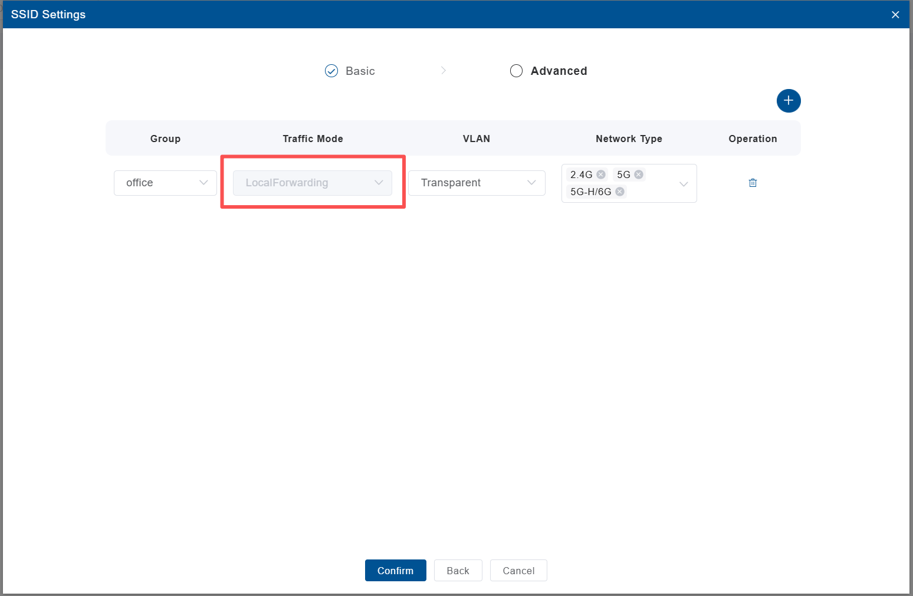
VM based AC can only support Local Forwarding Traffic mode.

- Enhancements
- None.
- Bug Fixes
- Topology: Fixed topology view display issues.
7. Known Issues
- None.
- Compatibility & Dependencies
- None.
- Upgrade Instructions
Please refer to the official guide document: Westala_UnifyAC_v1.0.5.8_Quick_Guide.docx
Deployment Prerequisite: When the LAN port of the primary AP cascades to a secondary AP, the cascaded port must be configured in Trunk + Transparent mode; otherwise, the Mesh/VLAN link may cannot be established.
10. Downgrade / Rollback
- Supported version: AC v1.1.0.x can be downgraded to v1.0.6.10 on both single-node and dual-node systems.
- Config compatibility: None
11. TAC Advisory
- Recommended upgrade scenarios:
- Known risks in previous versions:
- Deployment Notes
- None.
13. PoE Power Budget
Not applicable
14. Thermal Advisory
- Passive Heat Dissipation, do not cover the surface with any objects
15. Security Updates
Not applicable
16. Documentation & Support
- Support: support@westalatech.com
17. Disclaimer
- Westala reserves the right to modify specifications without notice.

