
DPSK User
Configuration Guide

Unify Access Controller (UnifyAC)

Applicable Version: | UnifyAC_CR_1.0.6.0 or later and AP 1.0.56.8 or later
Document Type: | Configuration & Operations Guide
Audience: | Network Administrators,AC Operators
Date: | August 20, 2026

Revision: 1.0
Revision | Date | Description
1.0 | 2026-08-20 | Initial release
1.1 | 2026-09-30 | Added filtering by Permit MAC and VLAN

Table Of Content
1. Introduction 4
2. Prerequisites 4
3. Accessing DPSK User Management 4
4. Creating a DPSK User 5
5. Editing DPSK Users 7
6. Modifying SSID Rules 9
7. Deleting DPSK Users 10
8. Batch Import (XLSX) 10
9. Exporting DPSK Users 11
11. Troubleshooting 12
12. Best Practices 12
13. Appendix 13

1. Introduction

1.1 Purpose
This guide provides comprehensive, step-by-step instructions for configuring and managing DPSK (Dynamic Pre-Shared Key) users on the Westala Unify Access Controller (UnifyAC). It is designed to help network administrators efficiently deploy, monitor, and maintain per-user PSK credentials in enterprise wireless environments.

1.2 Scope
This manual applies to the Web UI management of DPSK user life-cycle operations on UnifyAC firmware version UnifyAC_CR_1.1.0.5 and later. It covers user creation, editing, batch operations, SSID/rule binding, access control, expiration policies, and troubleshooting.

1.3 Terminology
Term | Description
DPSK | Dynamic Pre-Shared Key — a per-user PSK credential for Wi-Fi authentication
AC | Access Controller (UnifyAC)
SSID | Service Set Identifier — the Wi-Fi network name
VID | VLAN ID — Virtual LAN identifier for traffic segmentation
Tx / Rx | Transmit (upload) / Receive (download) bandwidth limits
Batch Edit | Simultaneous editing of multiple DPSK users
Import / Export | Bulk user management via XLSX file upload/download

2. Prerequisites
- UnifyAC firmware version UnifyAC_CR_1.0.6.0 or later
- AP firmware version 1.0.58.10 or later
- Supported web browsers: Chrome, Firefox, Edge (latest versions recommended)
- Administrator or Operator role with DPSK configuration privileges
- At least one SSID configured on the UnifyAC prior to DPSK user creation

3. Accessing DPSK User Management
Log in to the UnifyAC Web UI using an administrator account. Navigate to the DPSK User Management page using the following path:
Settings→ WiFi→ DPSK
The DPSK Users interface displays a complete list of existing users, their status, expiration time, bound SSIDs, and DPSK passwords (masked by default). Use the search box to filter by username or Permit Macs and the drop-down filters to filter by SSID, Status or VLAN.
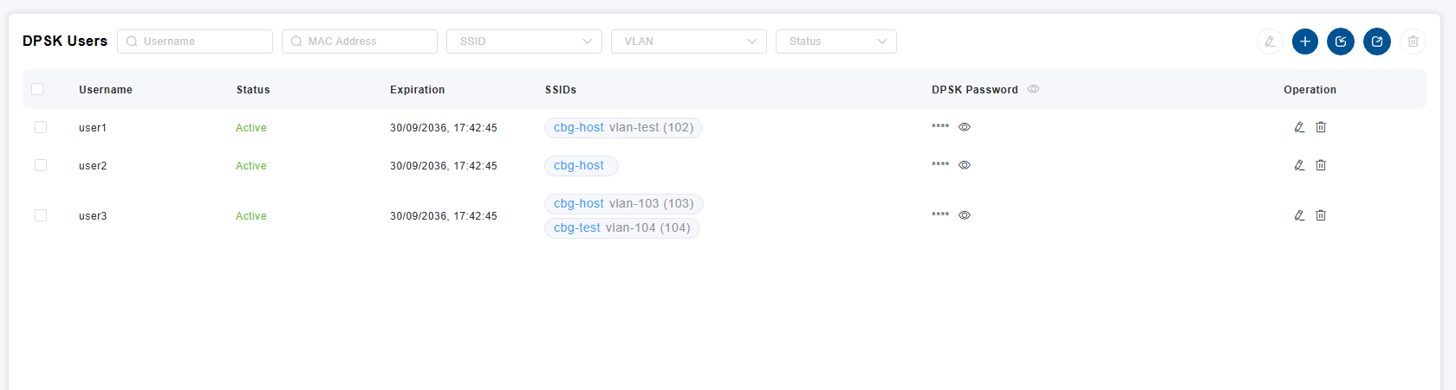
Figure 1 — DPSK Users List View

3.1 Toolbar Functions
The top-right corner of the DPSK Users list contains the following action buttons, ordered from left to right:

# | Button | Function | Description
1 | Batch Edit | Batch Edit | Select multiple users via checkbox, then click to modify common attributes (e.g., Active status, Expire Time) for all selected users simultaneously
2 | Add | Add | Create a new single DPSK user
3 | Import | Import | Open the Batch Import dialog to upload multiple users via an excel template
4 | Export | Export | Export the current DPSK user list to an excel file for backup or offline review
5 | Delete | Delete | Delete selected user(s)

Tip: Hover over any toolbar icon to display a tool-tip describing its function.

4. Creating a DPSK User
To create a new DPSK user, click the Add (+) button in the toolbar. The User configuration modal will appear with three sections: Basic, SSID & Rule, and Access Control.

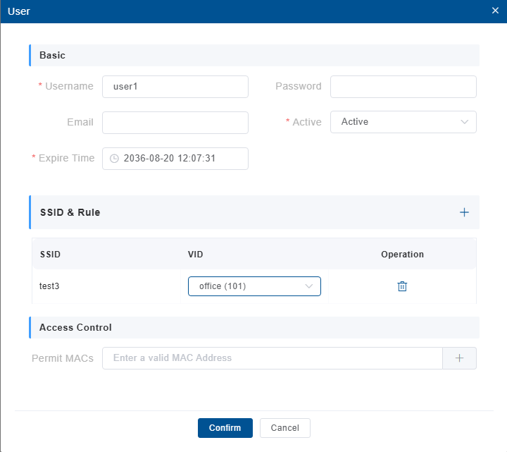
Figure 2 — User Creation: Basic Settings

4.1 Basic Settings

Field | Required | Description
Username | Yes | Enter a unique identifier for the DPSK user (e.g., user1, john_doe)
Password | No | Leave blank for auto-generation, or manually enter a custom password
Email | No | Enter the user’s email address
Active | Yes | Set to Active to enable the account, or Inactive to disable it
Expire Time | Yes | Set the account expiration date and time (Format: YYYY-MM-DD HH:MM:SS)

4.2 SSID & Rule
In this section, bind the user to specific SSIDs and define network policies:
Field | Description
SSID | Select the target SSID from the drop-down list
VID | Choose the VLAN ID (e.g., Transparent or a specific numeric VID such as 100)

✅ If no SSID is specified, the user is rejected on all SSIDs.
Click the + icon to add rules for additional SSIDs. Each SSID can have its own VID.

4.3 Access Control (Optional)
Restrict device access by MAC address for enhanced security:
- Enter a valid MAC address in the Permit MACs field.
- Click + to add it to the allowlist.
- Only devices with listed MAC addresses will be allowed to authenticate using this DPSK.
MAC binding is optional. If no MAC addresses are added, any device may connect using the DPSK credential.

4.4 Saving the User
After completing all required fields, click the Confirm button at the bottom of the modal to save the new DPSK user. Click Cancel to discard changes and close the modal.

5. Editing DPSK Users

5.1 Single User Edit
- Locate the target user in the DPSK Users list.
- Click the Edit (pencil) icon in the Operation column for that user.
- Modify the desired fields in the Edit modal.
- Click Confirm to save changes.

5.2 Batch Editing Users
The Batch Edit feature allows administrators to modify common attributes for multiple users simultaneously, saving significant time in large deployments.
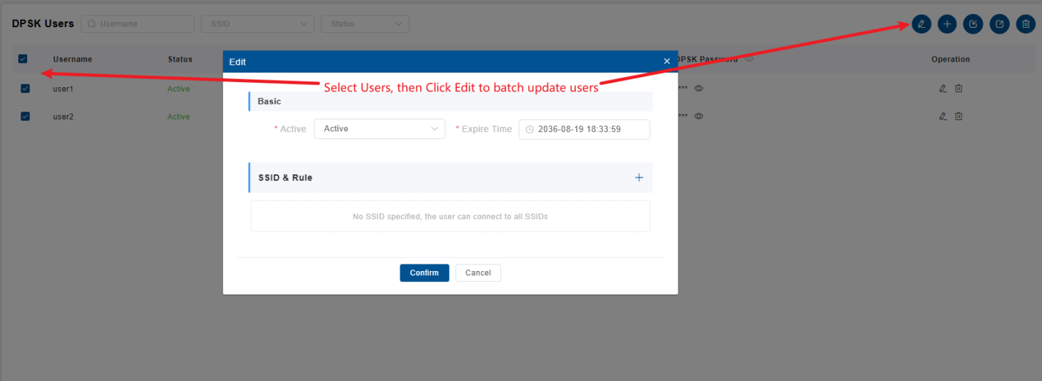
Figure 3 — Batch Edit Mode (select users, then click Batch Edit)

- Check the boxes next to the users you wish to update in the list.
- Click the Batch Edit button (pencil icon) in the top-right toolbar.
- In the Batch Edit modal, update the desired fields (e.g., change Active status or Expire Time).
- Click Confirm. The changes will be applied to all selected users.

6. Modifying SSID Rules
UnifyAC provides two convenient methods for modifying SSID rules for an existing user.

6.1 Inline SSID Rule Edit
To quickly adjust SSID network rules without opening the full edit modal:
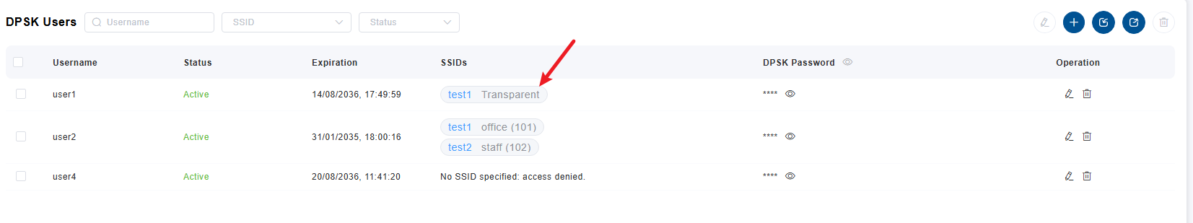
Figure 4 — Click the SSID field in the user list to edit rules inline

- Locate the user in the DPSK Users list.
- Click directly on the SSID tag in the SSIDs column (e.g., test1 Transparent).
- In the SSID Rule popup, modify the VID, or add/remove rules.
- Click Confirm to save the changes.

6.2 SSID Rule Configuration Modal
For more detailed SSID rule management, use the dedicated SSID Rule modal:
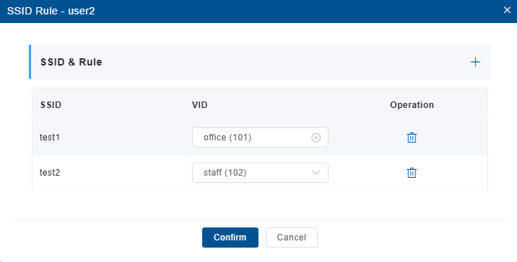
Figure 5 — SSID Rule Configuration Modal

Field | Description
SSID | The target SSID name
VID | VLAN ID drop-down (e.g., wan (100), Transparent)
Operation | Delete icon to remove a rule

Click the + button in the top-right of the modal to add additional SSID rules. Each rule can have independent VID.

7. Deleting DPSK Users
- Select the user(s) you wish to remove by checking the boxes next to their usernames.
- Click the Delete button (trash icon) in the top-right toolbar.
- Confirm the deletion action when prompted.

8. Batch Import (XLSX)
For mass deployment of DPSK users, UnifyAC supports bulk import via XLSX template. This is the most efficient method for on-boarding large numbers of users.

8.1 Import Dialog
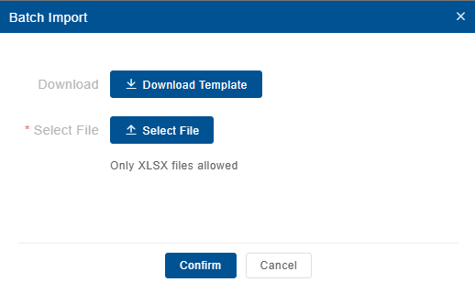
Figure 6 — Batch Import Dialog

- Click the Import button (upload icon) in the toolbar.
- In the Batch Import dialog, click Download Template to get the standard XLSX file.
- Fill in the template with the required user data.
- Click Select File to upload the completed XLSX (only .xlsx files are allowed).
- Click Confirm to process the import.

8.2 Template Fields Reference
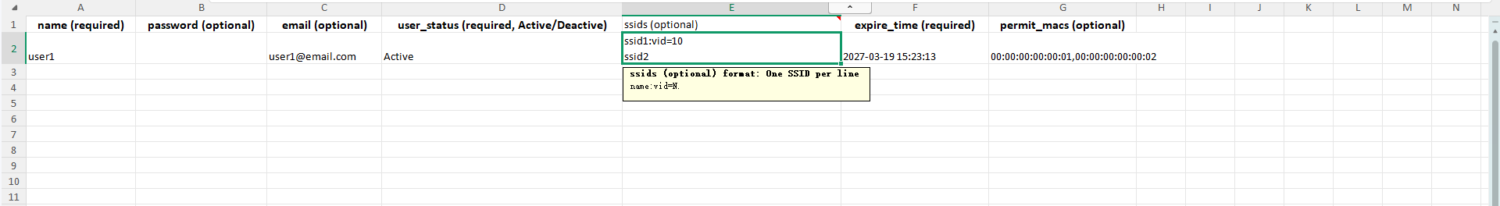
Figure 7 — XLSX Template with Example Data

Column | Required | Description
name | Yes | Username (unique identifier)
password | No | DPSK password (leave blank for auto-generation)
email | No | User email address
user_status | Yes | Active or Deactive
ssids | Yes | SSID rules (one per line, see syntax below)
expire_time | Yes | Format: YYYY-MM-DD HH:MM:SS
permit_macs | No | Comma-separated MAC addresses

8.3 SSID Rule Syntax
The ssids column in the XLSX template supports the following syntax for defining per-SSID rules:
Format: ssid_name:vid=N

Parameter | Description | Example
ssid_name | Name of the SSID | test1, ssid2
vid=N | VLAN ID (numeric) | vid=10, vid=100

Example SSID entries (each on a separate line within the cell):
ssid1:vid=10
ssid2

In the XLSX cell, each SSID rule must be on a separate line (use Alt+Enter in Excel to create a new line within a cell).

9. Exporting DPSK Users
Click the Export button (download icon) in the toolbar to export the current DPSK user list to an XLSX file. This is useful for:
- Creating backups of the current user database
- Offline review and auditing of active accounts
- Migrating users to another AC (export, then import)

11. Troubleshooting
Issue | Possible Cause | Resolution
User cannot connect | Account expired or status is Inactive | Verify the Expire Time and Active status in the user list. Update if necessary.
DPSK rejected | Incorrect password entered on the client device | Click the eye icon to reveal the correct password and re-enter it on the client.
MAC binding failure | Client MAC does not match the Permit MACs list | Ensure the device’s MAC address is correctly added to the user’s Access Control list.
Cannot access specific SSID | SSID Rule restricts the user to different SSIDs | Edit the user’s SSID & Rule section to ensure the target SSID is included.
Import file fails | Incorrect file format or syntax error in XLSX | Ensure the file is .xlsx and the ssids column follows the exact required syntax.
User connects but has no internet | VLAN or VID misconfiguration | Verify the VID setting in the SSID rule matches the network’s VLAN configuration.

12. Best Practices
- Set Expiration: Always define an Expire Time for temporary guests or contractors to ensure automatic deactivation.
- VLAN Segmentation: Use specific VIDs in SSID rules to segment user traffic for security and policy enforcement.
- MAC Binding: Enable MAC-based access control for high-security environments (e.g., corporate executives, finance departments).
- Regular Audits: Periodically export the DPSK list to review active users and remove obsolete accounts.
- Bulk Operations: Use Batch Import for initial deployment and Batch Edit for mass updates to save administrative time.

13. Appendix

13.1 Example User Entry
Field | Value
Username | user1
Password | Auto-generated
Email | user1@email.com
Status | Active
Expire Time | 2036-08-19 18:32:08
SSIDs | test1 (VID 100)
MAC Control | 11:22:33:44:55:66

13.2 Support
For additional assistance, please contact Westala Technical Support or refer to the UnifyAC Administrator Reference Manual.

